**ASE LAB 3 ASSISTMENT**

I have created a mash up application that includes directions map from one place to another and also google chart showing percentage of students at two places.

The google map shows directions between the two predefined places University of Missouri – Kansas City (UMKC) and University of Missouri-St. Louis (UMSL). Directions render is used to show the directions between UMKC and UMSL.

The other application is google chart displaying the student population in UMKC and UMSL. Two different colors are used in chart to show the distinction between the two.

We can also connect to social networking like Facebook and Twitter and can like, share, comment and tweet on the posts.

1. The screenshot of map showing directions from UMKC to UMSL is shown in the figure below:

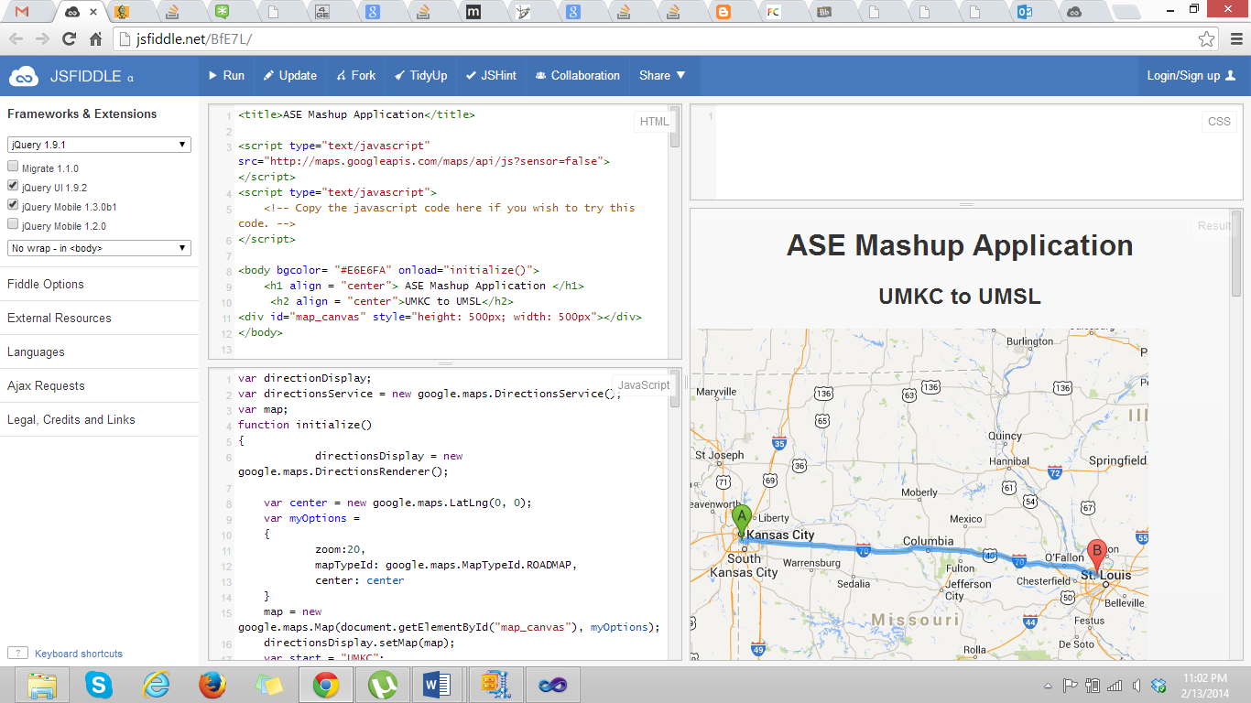

1. The google chart displaying student percentage is shown.

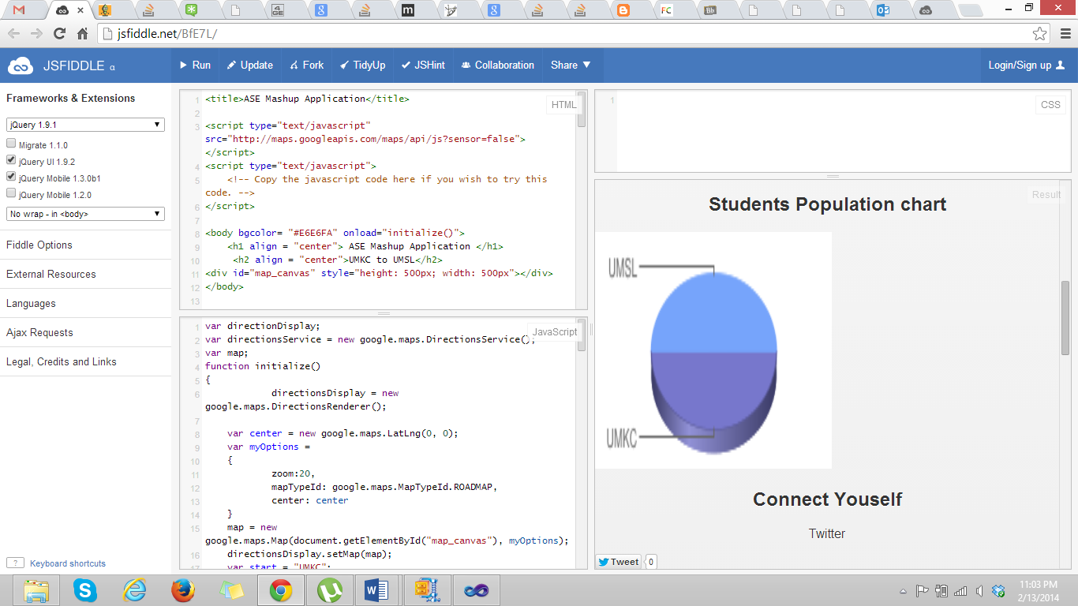

1. The screenshot below shows social network connections i.e., twitter and Facebook, where we can like, comment or tweet on the posts.

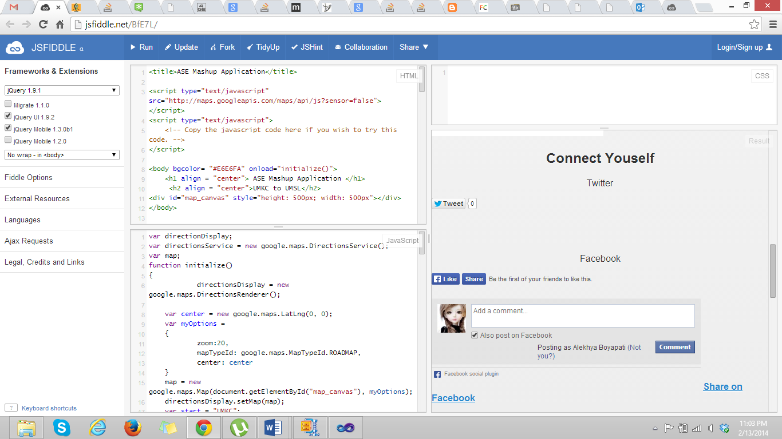

Screenshots were also taken using Opera Mobile. They are:

